Analyzing NITROGEN BLOWER VIBRATION
Ken Singleton

Manager KSC Consulting LLC
19676 Serenity Lane
Bristol VA 24202
ksingleton@vibrationconsulting.com

Abstract:
Two Nitrogen Blowers were critical assets in a manufacturing facility but their reliability was poor due to regular bearing failures and high amplitude vibration. The blowers were of typical construction with a channel frame base mounted on spring isolators, a fabricated box supporting the spherical double ball bearings, and belt driven by a VFD motor. Standard vibration analysis was conducted periodically to determine when to change out the bearings.
A detailed analysis using visual inspection, standard Operating Deflection Shape (ODS), Video ODS and Rotor Modeling were performed to identify potential reliability improvements. Beefing up the frame and bearing support, changing to a tunnel bearing design were considered to improve bearing reliability. The traditional ODS and Video ODS identified frame flexure and the bearings rocking on the thin bearing housing support plate. Visual inspection identified short keys generating unbalance, long bolts at the impeller hub generating unbalance and fretting of the tapered sleeves retaining the bearings to the shaft.
Keywords: Operating Deflection Shape (ODS), video ODS, Peakvue, critical speed

Introduction:
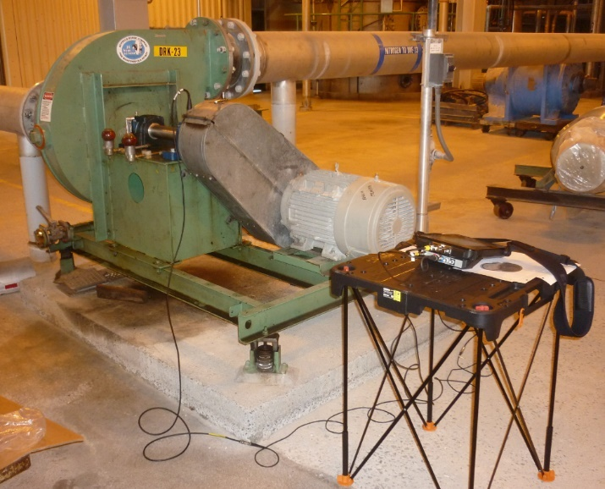
One of the blowers, see Figure 1, showed the typical construction. The frame was fabricated of 6” Channel and supported at the corners by spring isolators. The bearings were mounted on a fabricated box of 5/16” thick plate. The motor was 25 HP VFD and transferred power to the blower shaft using Dayco BX 65 belts. Blower bearings were SKF 1216 K two row spherical ball with tapered sleeve. The tapered sleeve is used to simplify installation but fretting corrosion between the sleeve and shaft and the sleeve and bearing bore is a reliability problem observed on other fans and blowers. Typical run speeds were Motor 1779 RPM and Blower 2850 RPM (VFD @ 60 Hz). Emerson Peakvue measurements were made on each bearing and used to determine when the bearings should be changed out.
Figure 1: On-site photo of Nitrogen Blower During ODS Test.

Visual Inspection:

Visual inspection of DRK-23 blower identified the following:

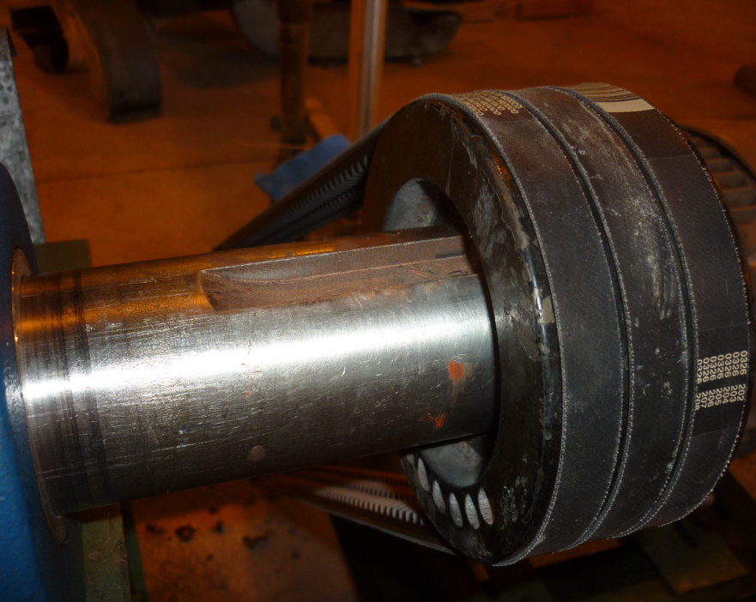
- The blower shaft sheave key was short generating about 47.3 lb_{f} unbalance.
Figure 2: Short Key at Sheave End. Unbalance Generated Calculated to 47.3 lb_{f}.

- The key was stepped, (sheave tapered sleeve had ½” keyway and the shaft had 5/8” keyway). A sketch of a replacement key is shown in Figure 3.

- The set screws in the spare impeller hub were too long and would generate unbalance, see Figure 5.

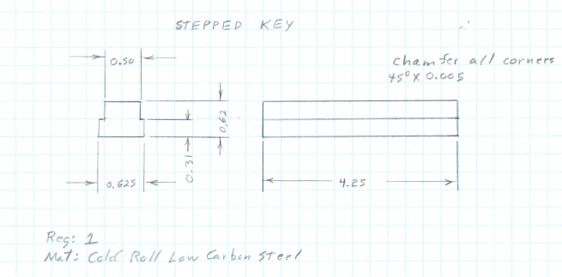
Figure 3: Sketch of Replacement Key for Blower Sheave End.
- The impeller (Figures 4 & 5) was fabricated with riveted blades to the cover and back plate. The set screws securing the hub to the shaft were ½ in square head and too long. Their excess length was calculated to generate about 37.3 lb_{f} unbalance. A recommendation was made to replace the square head set screws with socket head set screws of a length that would make the set screws flush with the hub OD when tight.

- The impeller weight was 98.6 lb_{f}. The dimensions of the impeller back plate, front cover, blades, hub and rivets were used in the rotor dynamic models.
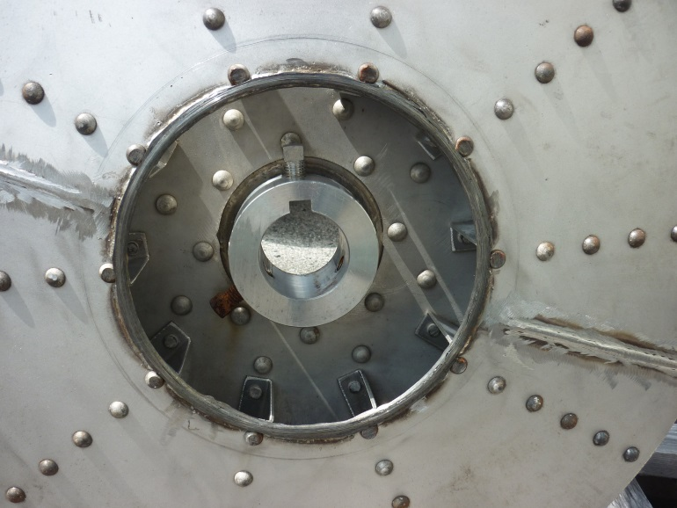
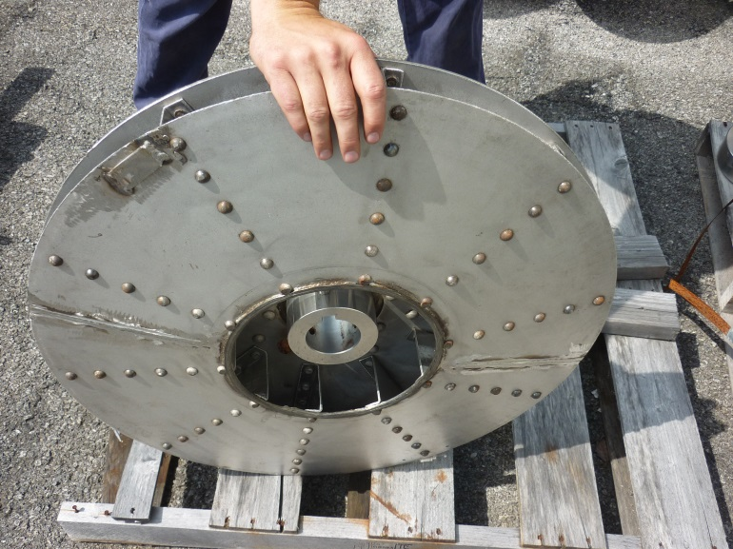
Figure 5: Nitrogen Blower Impeller. Showing Long Set Screws Which Would Generate Significant Unbalance.

Figure 4: Nitrogen Blower Impeller.

Power Transmitted by Belts:

A force is generated by the belts that produces work acting on the rim of a pulley or sheave. When the drive is transmitting power, there is a high tight side tension and a low slack side tension. The difference between the tensions (T_{t}-T_{s}) is called the effective pull. ^{Ref 3}
- Net pull = Effective pull = HP * 33,000/belt speed (fpm)
- Belt speed is directly related to pulley diameter. Double the diameter and the total belt pull is cut in half thus increasing bearing life. ^{Ref 3}
- Belts see three types of tension:
  - Working Tension (tight side-slack side). Tension ratio R = tight-side/slack-side. The larger R, the closer the belt is to slipping.
  - Bending Tension occurs when the belt bends around the pulley. One side is in tension, the other side in compression.
  - Centrifugal tension, occurs as the belt rotates around the drive.
T_{c}= MV²
Where: T_{c} = Centrifugal tension lb_{f}
M = Constant dependent on belt’s weight
V = Belt velocity in feet per minute
  - Neither the bending nor the centrifugal tension is are imposed on the pulley, shaft or bearing, only on the belt
Belts were Dayco BX 65.
The Net Pull = 25Hp * 33,000 Ft-lb/4500 = 183 lb_{f}. The horizontal and vertical components of the belt pull were calculated to 130 lb_{f} horizontal and 130 lb_{f} vertical. These values were used in the DyRoBeS rotor model as static loads at the sheave.

Vibration Data:
Vibration data was collected on the motor and blower bearing housings periodically. Vibration levels were especially high at the A Nitrogen Blower where dominant vibration occurred at the blower speed (Figures 6 & 7). Peakvue data was used to detect bearing fault development and trend the time domain peak amplitude (Figures 8 & 9).
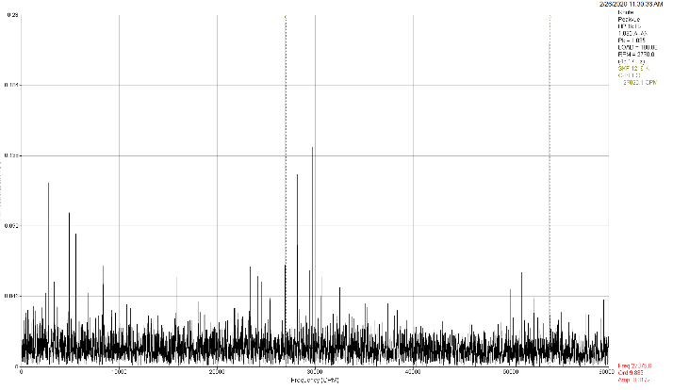
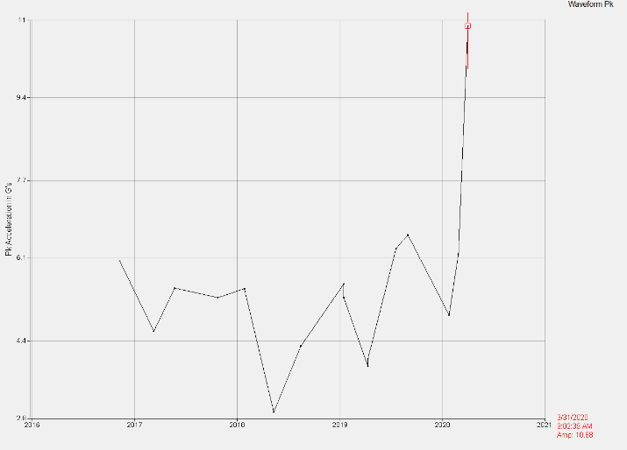
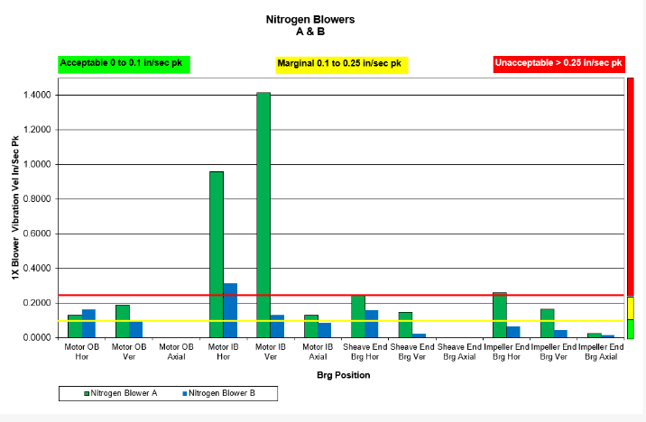
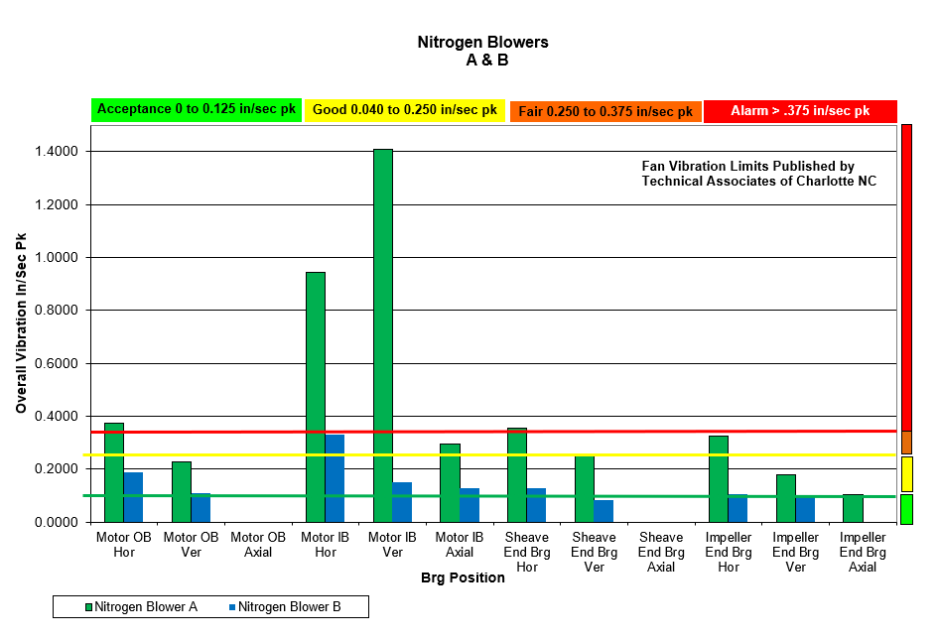
Figure 9: Peakvue Spectrum Showing BPFO and Sidebands.
Figure 8: Peakvue Time Waveform Trend.
Figure 7: Blower Run Speed Vibration For Blowers A & B.
Figure 6: Overall Vibration Motor and Blower Bearing Housings For Blowers A & B.
Rotor Dynamic Model – Existing Bearings:

Models of the blower rotor were developed using DyRoBeS ^{Ref 1} finite element-based software for the following:
- Existing straight shaft and SKF 1216K two row spherical ball bearings (SNL housings).
  - Sheave End SKF 1216K two row spherical ball bearings, stiffness = 741,567 lb_{f}/in
  - Impeller End SKF 1216K two row spherical ball bearings, stiffness = 519,052 lb_{f}/in
- SKF PDN 214 (tunnel bearing housing) with 6214 ball bearings. The shaft design for the tunnel bearing would need diameter modifications to fit the existing sheave and impeller.
  - Sheave End Ball Bearing, stiffness = 475,161 lb_{f}/in
  - Impeller End Ball Bearing, stiffness = 435,685 lb_{f}/in
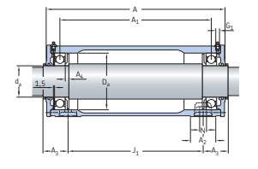
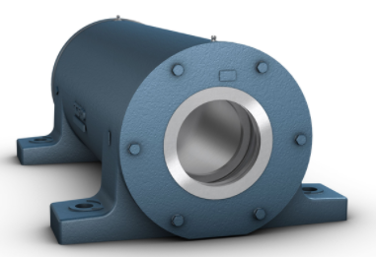
Figure 10: SKF PDN 214 Tunnel Bearing Housing.

The 6214 ball bearings were calculated to have a lower stiffness than the double row SKF 1216 K bearings but the PDN 214 housing, (Figure 10) was significantly stiffer than the SNL housings.

The rotor model using the SKF 1216 K bearings is shown in Figure 11. The bearing static loads and shaft deflection (0.0016 inch maximum) due to gravity and belt pull is shown in Figure 12. Bending stresses were considered low at maximum 645 PSI.

The rotor 1st flexural critical speed with existing SKF 1216 K two row spherical ball bearings and the pedestal dynamic mass and stiffness included calculated to 8,859 RPM, see Figure 13.
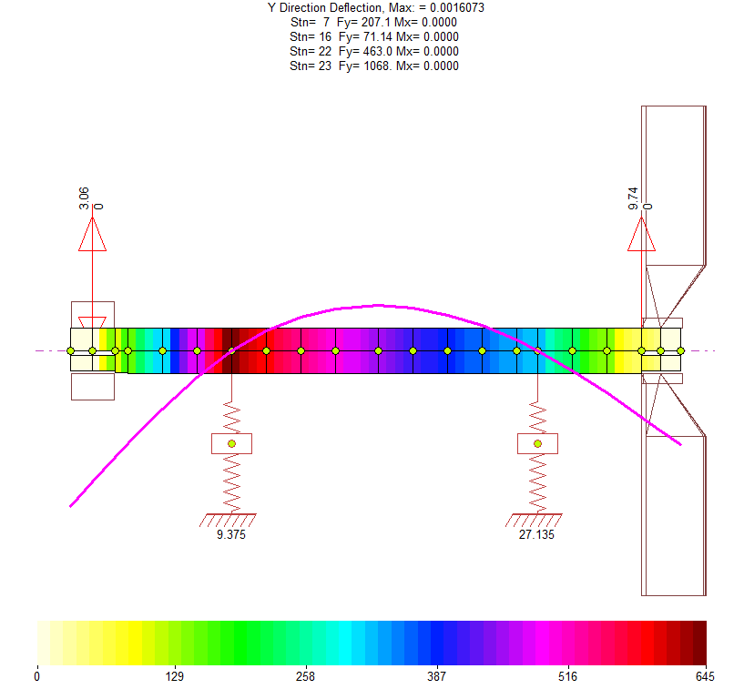
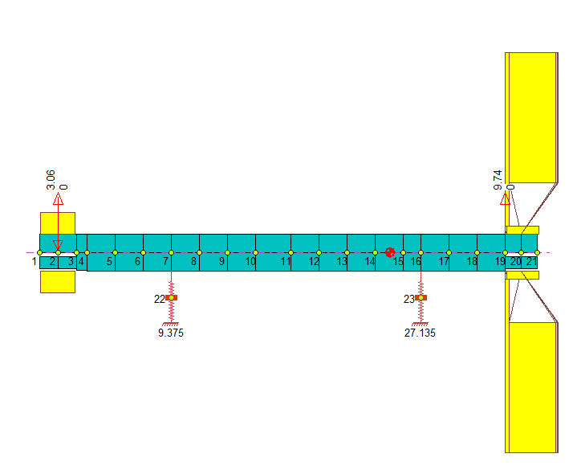
Figure 12: Nitrogen Blower Rotor Static Bearing Loads (SKF 1216K Two Row Spherical Ball Bearings) and Stresses in Bending.
Figure 11: Nitrogen Blower Rotor Model with SKF 1216K ball bearings, and Pedestal Mass & Stiffness.

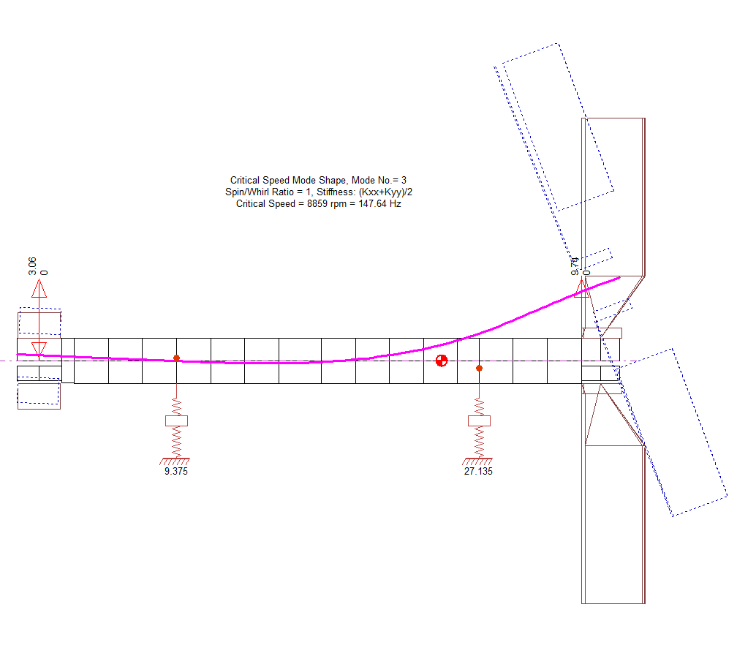
Figure 13: Nitrogen Blower Rotor (SKF 1216K Two Row Spherical Ball Bearings) 1st Flexural Critical 8859 RPM.

Rotor Model with PDN 214 Housing:

The rotor model with the SKF PDN 214 tunnel bearing housing and 6214 ball bearings is shown in Figure 14. The model with static bearing loads and bending stresses is shown in Figure 15. The sheave end bearing load calculated to 161.5 lb_{f} and the impeller end bearing to 124.5 lb_{f}. Minimum load for the 6214 bearing = 1% * 10,116 = 101 lb_{f}. Both bearings calculated to have the required minimum load.

The 1st critical flexural mode calculated to 5,934 RPM, see Figure 16. The critical speed with the tunnel bearing housing (PDN 214) was lower than with the SKF 1216 K double ball spherical bearings but still well above running speed.
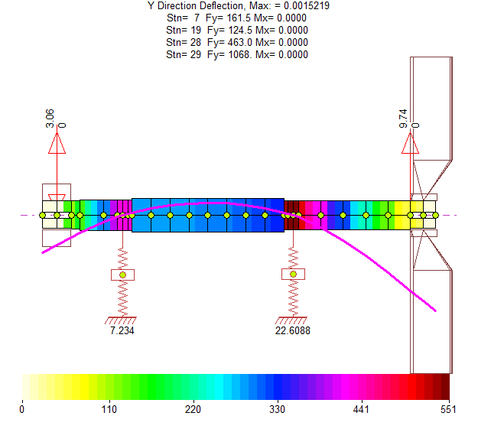
Figure 15: Nitrogen Blower Rotor With PDN 214 Housing and 6214 Ball Bearings, Static Bearing Loads and Bending Stresses.
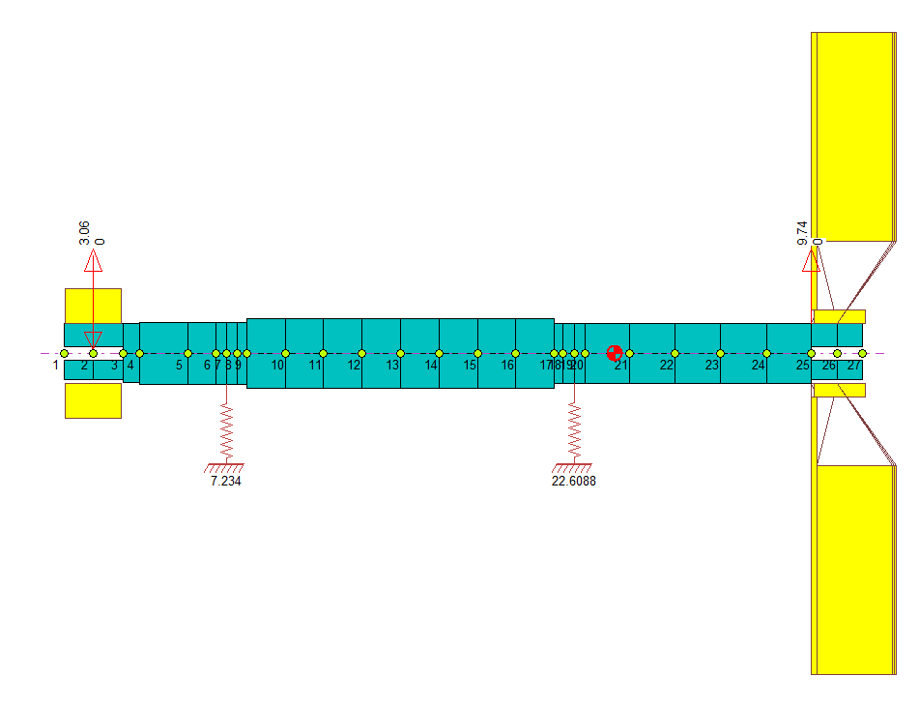
Figure 14: Nitrogen Blower Rotor Rotor Model With PDN 214 Housing and 6214 Ball Bearings.

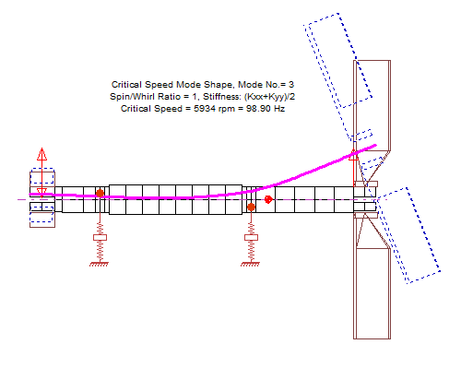
Figure 16: Fan 1st Critical Flexural Mode 5934 RPM With PDN 214 Tunnel Bearing Housing and 6214 Ball Bearings.

Traditional ODS:

The blower 3D drawing for the ODS was developed in MEscope ^{Ref 2} software, see Figures 17 & 18. The 3D model represents the fan frame, bearing pedestal, bearing housings, blower housing and the motor. Vibration was measured at 176 points in X, Y and Z directions where accessible. The ODS showed twisting and flexing of the frame and bearing pedestal and rocking of the blower bearing housings. Not supporting the bearing housings rigidly reduces their reliability due to relative movement of components.

The primary frequencies of vibration measured by traditional ODS were as follows:

MP4 Animation File | Description
Motor 1X Run Speed | 1,781 RPM - Motor 1x Run Speed. Point with highest vibration was Blower IB Bearing @ 0.465 in/sec pk.
Blower A 1X Blower Run Speed - 2,794 RPM | 2,794 RPM - Blower 1x Run Speed. Point with highest vibration was at the right rear corner of the frame @ 1.396 in/sec pk.
Blower A 2X Blower Run Speed – 5,588 cpm | 5,588 CPM - 2x Blower Run Speed. Point with highest vibration was at top of Blower Sheave End Bearing Housing @ 0.213 in/sec pk.
Blower A 3X Blower Run Speed - 8,391 cpm | 8,381 CPM - 3x Blower Run Speed. Point with highest vibration was corner of the frame near motor @ 0.270 in/sec pk.
Blower A 4X Blower Run Speed - 11,190 cpm | 11,190 CPM - 4x Blower Run Speed. Point with highest vibration was on the frame at right side near pedestal hold down bolt @ 0.195 in/sec pk.
Blower A 5X Blower Run Speed - 13,990 cpm | 13,988 CPM - 5x Blower Run Speed. Point with highest vibration was impeller end bearing housing @ 0.089 in/sec pk.

Animation files are provided for each frequency with this document.
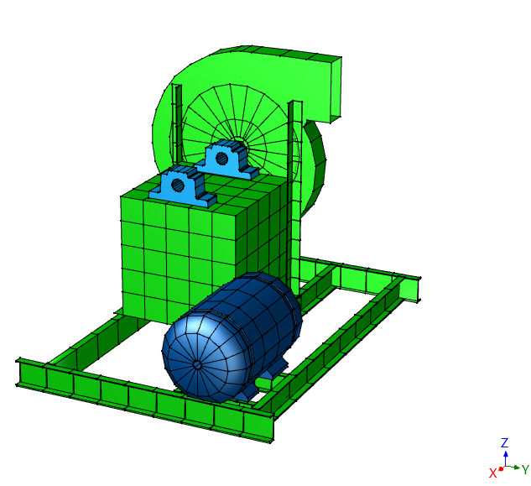
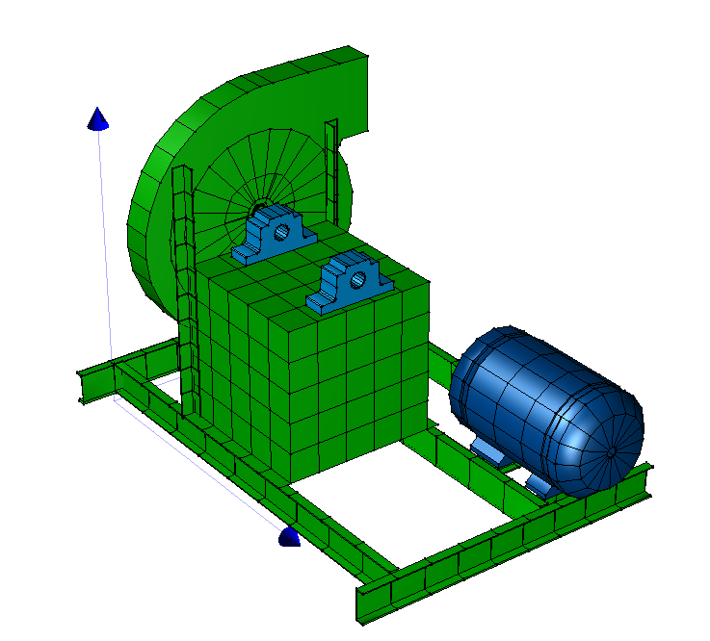
Figure 18: MEscope 3D Model of the Blower – View 2.
Figure 17: MEscope 3D Model of the Blower – View 1.

Video ODS:

After completing the traditional ODS, videos were recorded using a high-speed Cronos 1.2 Megapixel camera from different angles, see Figures 19-21. The high-speed videos were processed using MEscope. Frame twisting and belt guard vibration was clearly evident in the Video ODS‘s. The motor vertical vibration, see Figure 20, at 1X Blower Run Speed due to sheave unbalance and flexure of the adjustable motor support was clearly seen indicating an area for potential cracking of the adjustable motor support. Bearing housing rocking at higher frequencies was not clearly visible.
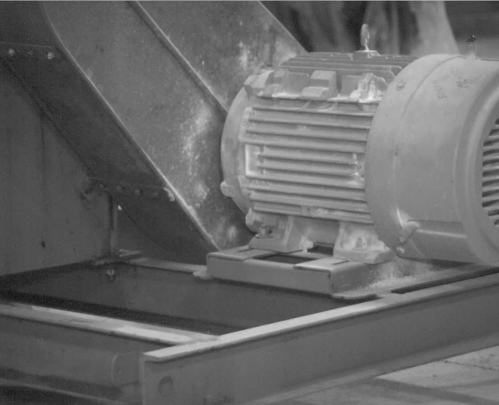
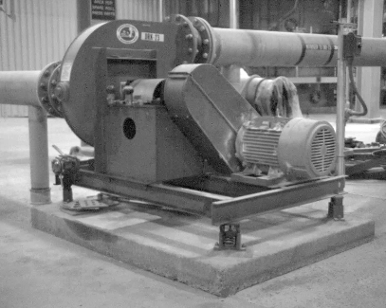
Figure 20: View of Motor and Adjustable Motor Support.
Figure 19: View Showing Motor, Belt Guard, Bearing Support Base and Channel Frame on Spring Isolators.

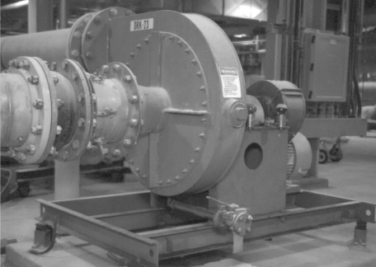
Figure 21: Suction Side of Blower With Flex Connection and Adjustable Turning Vanes.

Video ODS MP4 Animation File | Comment
ODS Video Blower A 1X Blower Run Speed | See still image Figure 19.
ODS Video of Motor at 1X Blower Run Speed | See still image Figure 20.
ODS Video Blower A Inlet Side Blower 1X Run Speed | See still image Figure 21.
Conclusions:

The Nitrogen blower design was typical of the offerings from many vendors. Flexible frame and bearing supports are unfortunately common. The corrective actions recommended were to beef up the blower frame and bearing housing support, replace the blower bearings & housings and balance the rotor per ISO 1940-1 to G2.5 or better.

- Consider modifying the blower frame and bearing pedestal as follows:
  - Stiffening the frame, which is fabricated using 6” channel by welding additional 6” channel to most of the elements or re-fabricate the frame using 6” wide flange beams and welding a cover plate of ½” steel to the entire frame (see notes Figure 22). The intent is to stiffen the frame to reduce torsional flexing / twisting.

  - Consider removing the bearing pedestal top plate (5/16” plate) and replacing with minimum 1” thick plate. Take cleanup cuts at the bearing housing mounting locations to machine these locations flat 0.001 to 0.002 inch per foot.

  - Consider stiffening the sides of the bearing pedestal by welding a plate of ½” steel inside the bearing pedestal (see Figure 23).

  - Replace the spring isolators with higher rated units since the beefed-up frame, pedestal and bearings will be heavier. The spring isolators should be specified to provide a minimum of 95% isolation from the lowest forcing frequency of 2x belt speed.

- Consider balancing the rotor per ISO 1940-1 to ISO G2.5 or better balance quality. Perform balancing in steps as follows:
  - Measure runout of the shaft to ensure runout is less than 0.001 inch.
  - Replace the square head set screws retaining the impeller to the shaft with set screws of a length that places the head of the set screws flush with the hub OD.
  - Install a half key at the sheave end.
  - Balance the rotor making corrections only on the impeller. Calculate the residual unbalance tolerance per ISO 1940-1 for overhung rotors.
  - Install the sheave with correctly sized key and balance the rotor making corrections only on the sheave.

- Consider replacing the existing two bearing housings and SKF 1216 K tapered bore bearings with an SKF PDN 214 with 6214 ball bearings. A new stepped shaft design will be required.
Figure 22: ME’scopeVES 3D Model of the Blower.
- Remove the Top Plate.
- Replace with minimum 1" thick plate.
- Machine the bearing housing mounting locations (after welding the plate in place) to 0.001 to 0.002 in/ft flat.
Replace Existing Bearings & Housings With SKF-PDN 214 Housing With 6214 Ball Bearings.
Replace Frame With 6” Wide Flange Beams and ½” Cover Plate Welded to the Beams.
Replace The Spring Isolators With Properly Sized Springs to Provide 95% Isolation.

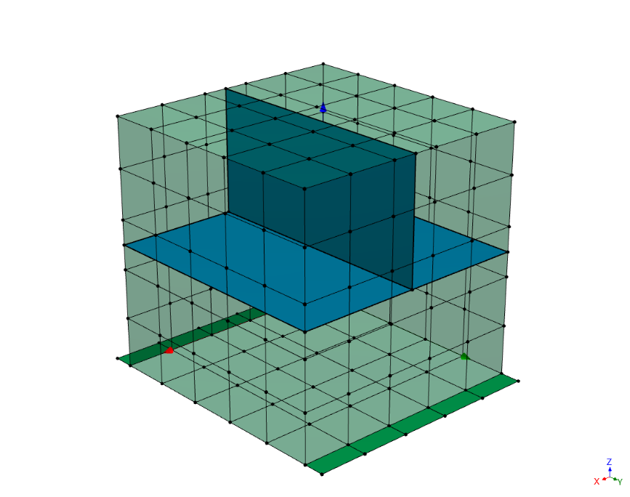
Figure 23. Internal Sniffers Recommended to Stiffen Bearing Support Box.
- Comparing traditional ODS and Video ODS, it appears they complement each other. Use of both technologies should be considered depending on the structure being analyzed.

  - Traditional ODS is more accurate since most analyzers today use 24-bit A/D as compared to video 12-bit CCD and data commonly stored as mp4 video which uses only 8-bits.
  - Traditional ODS and Experimental Modal Analysis are frequently used together.
  - Video ODS measures pixel displacement which means motion disappears rapidly as frequency increases.
  - Since video ODS is optical it is limited where the room is dark or where steam prevents a clear view of equipment such as a paper machine sheet, press felt, vacuum box, etc.
  - Video ODS is very effective measuring vibration of low mass structures such as coupling & belt guards, refrigeration tubing, chains, belts, appliances, oil lines and elevated structures such as piping and bridges, etc.
  - Additional lighting is often required indoors for video ODS or the images will be very dark and difficult to see clearly.
  - Camera shake/vibration can be a problem. Camera vibration caused by initiating/stopping data capture can be edited out in MEscope if the recording is several seconds long.
  - Data for traditional ODS can be taken at locations where the structure cannot be visually seen.
  - Traditional ODS requires building a 3D Drawing (requires some time depending on drawing complexity) on which the data is linked for animation. The 3D Drawing can be viewed from any angle unlike video ODS.
  - Aliasing for video ODS is a potential problem since there is no way to separate the motion within the sampling frequency from motion occurring outside the sampling frequency. Rule of thumb is to set the frames per second to slightly more than two times the highest frequency desired to measure. Vibration components above one-half the recording frequency (frames per second) of the camera will alias into the video frames.
  - Since anti-alias filtering cannot be used with video recording, care must be taken when analyzing data from a high-speed video.

References:

- Chen, W.J., Ph.D.,P.E., DyRoBeS Rotor, www.DyRoBeS.com
- MEscope, http://www.vibetech.com
- Machinery’s Handbook 24th Edition Pg 2284
- Singleton, K., Barbee, A., Bracher, B., McGinnis, B.; Case Study, Analysis of Process Fan Failure And Bearing Housing/Shaft Design, 2013 Vibration Institute Training Conference.
- Unbrako Engineering Guide, Pg 17. Unbrako USA, 11939 Woodruff Ave, Downey, CA 90241.

